**List of Changes requested for CPF planning module**

1. Move this platform site to the CPF workspace by including a new section just under “CPF formulation Status”. The title can be “CPF planning, monitoring and reporting tool” (see below example). Under the main title, there can be three sub-sections 1) planning, 2) monitoring, and 3) reporting. The users can already begin using the planning module as it is complete. Regarding the monitoring and reporting modules, when they click on it, there should be a message which comes up saying “THIS MODULE IS CURRENTLY UNDER DEVELOPMENT” in big bold font.

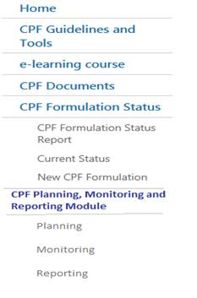

1. Changes to the home page. On the main home page of the planning module, kindly remove the “Go to current CWP” as the CWPs will be under the monitoring module once developed. Also please remove the “Active projects by FAO SO” (see below). The Country Work Plan title on the top of the page can also be removed **DONE**
2. Update the list of corporate output indicators to reflect the new list (2018-19), including short description. It should be a direct link with PIRES
3. Include linkage between CPF indicator target and Regional Initiative. Users can only be allowed to link one CPF indicator Target with one RI. The list of Regional initiatives will be directly retrieved from PIRES DB
4. A drop down list for each country that shows the CPF indicator targets grouped according to the year.
5. A drop down list for each country that shows CPF indicator targets according to corporate output indicators.
6. Ability to export information that has been inserted (in excel or word format).
7. The Global overview in the Planning Module has not been developed. One should be able to see CPF indicator targets grouped by Regional Office, and by corporate output indicator, and year of achievement.
8. Development of a view of all CPF indicator targets by country to be linked from PIRES

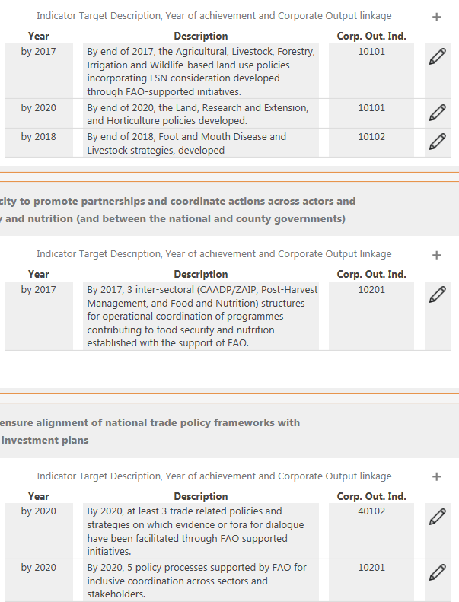

OTHER

1. OSP Director is wondering if it is possible to have visit statistics of the CPF workspace: <https://workspace.fao.org/osp/cpf/home.aspx>