THIXOTROPY OF CELLULOSE NANOCRYSTAL SUSPENSIONS

Savvas G. Frigaard^{,2}, Second Author^{3,2}, Third Author^{2,4} and Fourth Author^{1,4}
¹Canadian University of Rheology, Vancouver, Canada
²University of Sharkskin, Extrusionville, Canada
³Affiliation and address
⁴Affiliation and address

ABSTRACT
This document is a presentation of the template for abstracts to be submitted to the 8th Pacific Rim Conference on Rheology. The abstract shall reflect the content of the presentation to be made at the conference (oral or poster). The abstract should total between one and three pages, must be written using this template and uploaded in pdf format only. Retain the MS Word or Latex original in case of need to adjust.

PARAGRAPHS AND FONT
The first section should be an abstract. The abstract title line should follow 24 mm below the last author affiliation line. A one page submission may need only the abstract heading above, plus references (at end, if any are made). For longer submissions, please section as is appropriate for your document and results.
The text area should consist of a 16.8 cm wide centred area on a Letter-size sheet of paper. The title should start on a line 4.5 cm from top. The title should be capitalised. 9 mm underneath the title the author names should be listed, separated by a comma, with a superscript number reference to their affiliation and address. The affiliation and addresses should follow 9 mm below the author listing.
All lines should be single spacing. The abstract title should be printed in 16-point Calibri Light all caps bold. Major section titles should be printed in 12-point Arial all caps bold. Minor section titles should be printed in 12-point Arial bold. The bulk text should be printed in the 12-point Times New Roman font.
All section titles and the first paragraph of a section should start at the left-hand end of the printed area. All other paragraphs should start with a 7.5 mm indent. There are no page numbers. Please do not add them.

FIGURES, EQUATIONS AND TABLES
For references to figures in the text, please write Fig. number, in bold face as in the following example: See Fig. 1. The figures should be centred on the page. Small figures may be placed besides each other. Figure caption should be FIGURE followed by the number and colon, written out in 10 pt Arial bold face. Figure caption text should be in 10 pt Arial and should be centred underneath each figure.

${\dot{γ}}_{w}=\frac{12U}{d_{o}-d_{i}}\frac{2n^{'}+1}{3n^{'}}$ (1)

Equations should be centered. The equations shall be numbered with the equation number written in brackets to the right. Please make sure it is enough space above and below (and in between) the equations to ensure easy reading in a good-looking text. Reference to equations in the text shall be Eq. followed by the number. An example is shown in Eq. 1.
Tables should be placed similarly to figures. Table caption should be written in a similar way as the figure caption, however placed above the tables. Text reference to tables should be Table followed by the table number using bold face.

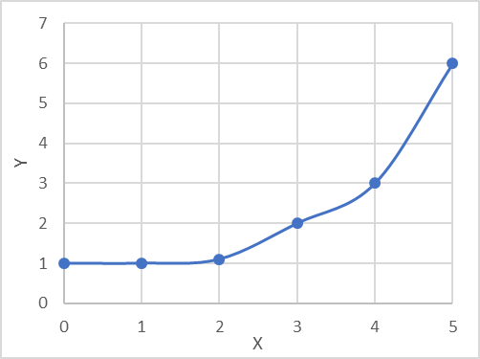
FIGURE 1: Example of figure placement and figure caption

ACKNOWLEDGEMENTS
You may include a funding or other acknowledgement, just before the references. We are grateful to the editors of the Annual Transactions of the Nordic Rheology Society for allowing us to recycle their template!

REFERENCES
In-text citations
For references to documents referred to in the reference list, use superscript sequentially^{1–6}. Author names may be used together with a superscript number.

Bibliography
The reference list shall be written in 10 pt Arial fonts. Bibliography should be formatted according to the ACS style⁶. All papers published in the Annual Transactions of the Nordic Rheology Society and similar shall be referred to as journal references⁵.

1. Frigaard, I. A.; Paso, K. G.; de Souza Mendes, P. R. Bingham’s Model in the Oil and Gas Industry. Rheol. Acta 2017, 56 (3), 259–282. https://doi.org/10.1007/s00397-017-0999-y.
2. Watson, J. H. The Diabolical Case of the Recurring Yield Stress. Appl. Rheol. 2004, 14 (1), 40–45. https://doi.org/http://doi.org/10.3933/ApplRheol-14-40.
3. Caenn, R.; Darley, H. C. H.; Gray, G. R. Composition and Properties of Drilling and Completion Fluids, 5th ed.; Gulf Publ Co, 1988.
4. Bjørkevoll, K. S.; Rommetveit, R.; Aas, B.; Gjeraldstveit, H.; Merlo, A. Transient Gel Breaking Model for Critical Wells Applications with Field Data Verification. In SPE/IADC Drilling Conference; 2003. https://doi.org/10.2118/79843-ms.
5. Maxey, J. Rheological Analysis of Static and Dynamic Sag in Drilling Fluids. Annu. Trans. Nord. Rheol. Soc. 2007, 15, 181–188.
6. ACS Style Quick Guide. In The ACS Guide to Scholarly Communication; 2020. https://doi.org/10.1021/acsguide.40303.

